How to Please Your I.T. Department
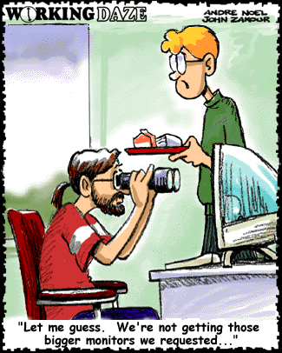

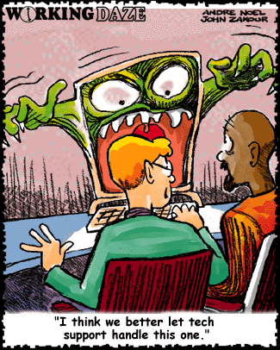
1. When you call us to have your computer moved, be sure to leave it buried under half a ton of postcards, baby pictures, stuffed animals, dried flowers, bowling trophies and children's art. We don't have a life, and we find it deeply moving to catch a fleeting glimpse of yours.
2. Don't write anything down. Ever. We can play back the error messages from here.
3. When an I.T. person says he's coming right over, go for coffee. That way you won't be there when we need your password. It's nothing for us to remember 700 screen saver passwords.
4. When you call the help desk, state what you want, not what's keeping you from getting it. We don't need to know that you can't get into your mail because your computer won't power on at all.
5. When I.T. support sends you an E-Mail with high importance, delete it at once. We're just testing.
6. When an I.T. person is eating lunch at his desk, walk right in and spill your guts right out. We exist only to serve.
7. Send urgent email all in uppercase. The mail server picks it up and flags it as a rush delivery.
8. When the photocopier doesn't work, call computer support. There's electronics in it.
9. When something's wrong with your home PC, dump it on an I.T. person's chair with no name, no phone number and no description of the problem. We love a puzzle.
10. When an I.T. person tells you that computer screens don't have cartridges in them, argue. We love a good argument.
11. When an I.T. person tells you that he'll be there shortly, reply in a scathing tone of voice: "And just how many weeks do you mean by shortly?" That motivates us.
12. When the printer won't print, re-send the job at least 20 times. Print jobs frequently get sucked into black holes.
13. When the printer still won't print after 20 tries, send the job to all 68 printers in the company. One of them is bound to work.
14. Don't learn the proper term for anything technical. We know exactly what you mean by "My thingy blew up".
15. Don't use on-line help. On-line help is for wimps.

